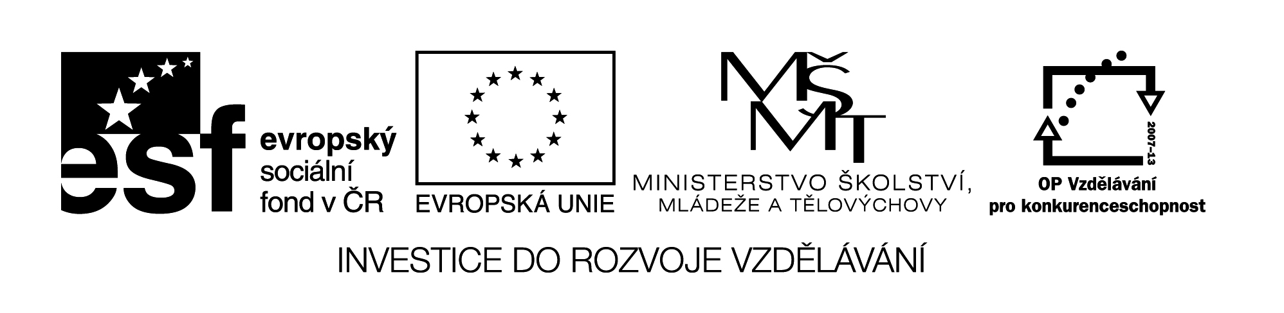

**Název školy:** Střední průmyslová škola, Ostrava - Vítkovice, příspěvková organizace

**Autor:** Mgr. Dagmar Andrysová

**Datum:** 27.7.2012

**Název:** VY_22_INOVACE_1_2_30

**Číslo projektu:** CZ.1.07/1.5.00/34.0125

**Téma:** Nepřímá řeč – pracovní list

**Anotace:** DUM; Dokument slouží k procvičení a zopakování učiva Nepřímá řeč. Žáci si ústně i písemně opakují učivo

**Reported Speech**

**Nepřímá řeč**

(pracovní list)

1. **Reprodukujte, co vám bylo řečeno. (začněte *She told me* nebo *He said*)**
2. We must finish our studies soon.
3. I can help you.
4. They will stay with us.
5. We rebuilt the cottage.
6. Our friends will wait for you here.
7. The record was created in 1993.
8. Stand up!
9. Suzie is waiting for us.
10. Don´t sleep at school.
11. We have done all our homeworks.
12. **Řekněte, co chtěli vědět. *(They wanted to know….)***
13. Where did you meet him?
14. What do you know about this country?
15. Will the company pay you in cash?
16. When is she leaving the school?
17. **Napište / řekněte původní otázku.**
18. He asked her if Maggie liked fish.
19. Tim asked me where I lived.
20. Tom asked Jenny when she had last seen her parents.
21. Pam asked me if I´d like a drink.
22. Our teacher asked us when we would do our homeworks.
23. His parents asked Peter who he was going to invite to his party.
24. **Převeďte následující citáty do nepřímé řeči.**
25. “When I grow up I want to be a little boy.” (Joseph Heller)

When someone asked J. Heller what he ________ to be when he __________ he _____ he _________ to be a little boy. (want, grow up, say, want)

1. “I am happy to say someone has stolen my wife´s credit card. He will probably spend a lot less than she does.” (Anon)

A man __________ he _________ delighted that someone ___________ his wife´s credit card. He ___________sure the thief ­­­­­­­­__________ less money than his wife. (say, be, steal, be, spend)

1. **Kamarádka vám tvrdí opak toho, co dříve. Vyjádřete překvapení**.
2. “That restaurant is cheap.”

Is it? I thought you said _________________

1. “Mary is coming to the party tonight.”

Is she? I thought you said________________

1. “Jane likes her father.”

Does she? I thought you said_____________

1. “I haven´t been to the cinema for ages.!

Really? I thought you said_______________

1. “Peter will come next weekend.”

Will he? I thougt you said _______________

1. “I can speak a little Spanish.”

Really? I thought you said _______________

1. **Přeložte do češtiny nebo angličtiny:**
2. Petr řekl, že nedávno viděl Jane.
3. Zeptala se ho, jestli nemá čas.
4. Učitelka nám řekla ať to neděláme.
5. Sue řekla, že zítra nepůjde do školy.
6. Děti se ptaly, kdy začala 2. světová válka.
7. Tom řekl, že na ten večírek nejde.
8. She told me that she wasn´t very well.
9. Peter asked me if I wanted to go out with him.
10. He said me that he had bought a new car.
11. John asked me where my sister would stay in London.
12. My parents told me to be back to midnight.
13. We told our children that we had been living in Africa for two years.

**Seznam použité literatury:**

English grammar in Use, nakl. Cambridge, 2009

Intermediate English Grammar, nakl. Collins Cobuild, 2004

Angličtina pro jazykové školy II., nakl. Fortuna, 2000