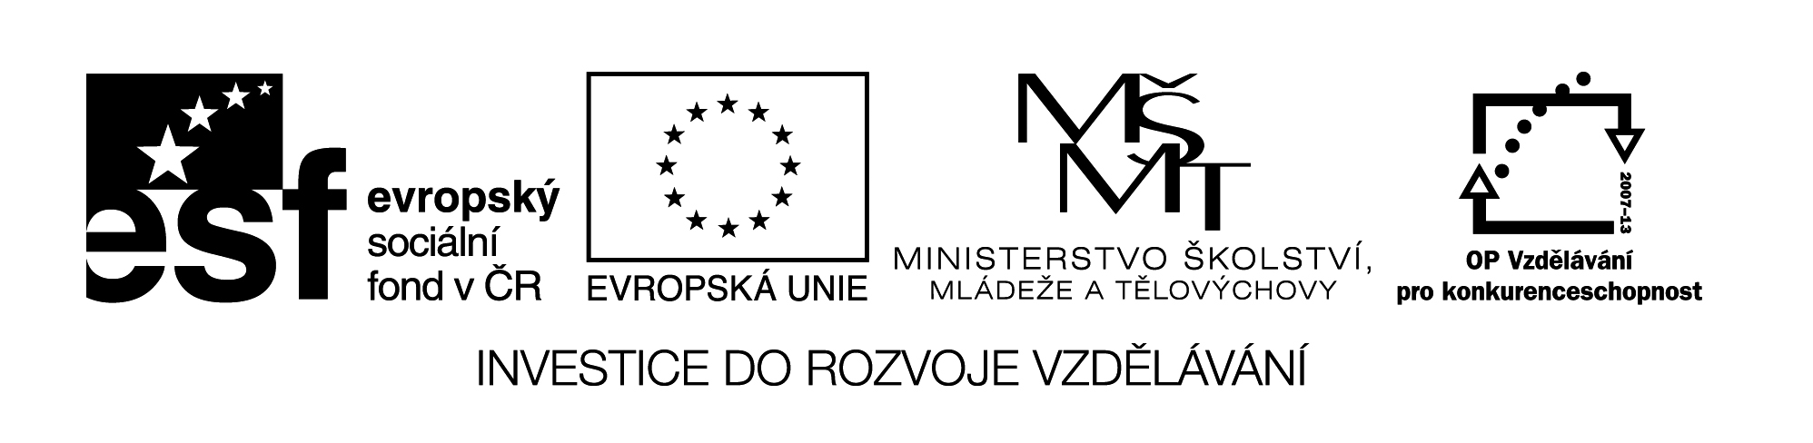

**Název školy:** Střední průmyslová škola, Ostrava - Vítkovice, příspěvková organizace

**Autor:** Mgr. Dagmar Andrysová

**Datum:** 31.7.2012

**Název:** VY_22_INOVACE_1_2_20

**Číslo projektu:** CZ.1.07/1.5.00/34.0125

**Téma:** Zájmena – pracovní list

**Anotace:** DUM; Dokument slouží k procvičení a zopakování učiva Zájmena. Žáci si ústně i písemně opakují učivo.

**Pronouns**

**Zájmena**

(pracovní list)

1. **Nahraďte podtržená slova zájmeny.**
2. Sue will help her mother in the kitchen.
3. Children like playing with friends.
4. Tom will go to England with Mary and her sister.
5. I like my English teacher but Peter likes our Maths teacher more.
6. **Doplňte zvratná zájmena.**
7. I´d like to introduce ________________. I am John Lennon.
8. He looked at _______________ in the mirror.
9. She should take care of _____________ .
10. Tom and Jerry, don´t hurt ______________ .
11. Don´t worry about us. We can look after ______________ .
12. “Can I take another biscuit?” “Of course, help __________ .”
13. **“–selves” nebo “each other”?**
14. How long have you and Tim know __________ ?
15. Some people are very sefish. They only think about ____________ .
16. In Britain friends often give presents to _________ at Christmas.
17. Judy and I don´t see ____________ very often these days.
18. If somebody attacks you, you must be able to defend __________ .
19. We´d never met before, so we introduced _____________ to _______________ .
20. **Doplňte *some* nebo *any*, případně jejich složeniny *(-body, -thing, where).***
21. We didn´t buy _______ flowers.
22. There is ________ at the door. Can you go and see who it is?
23. This evening I´m going out with _______ friends of mine.
24. Have you seen _____ good films recently? – No, I haven´t.
25. I wasn´t hungry, so I didn´t eat ________ .
26. I didn´t have ________ money, so I had to borrow ______ .
27. They stay at home all the time. You can never see them going ________ .
28. This machine is very easy to use. _________ can learn it.

1. **Odpovězte krátce záporně na otázky a pak odpovědi přepište do záporných vět.**

**Příklad**: What did you do? *Nothing. I didn´t do anything.*

1. Who were you talking to?
2. How much luggage have you got?
3. Where are you going?
4. How many mistakes did you make?
5. How much did you pay?
6. **Přeložte do češtiny nebo angličtiny.**
7. To je Petra. Je to žena mého bratra.
8. To nebyla moje chyba. Byla jeho.
9. Máš ve (svých) vlasech pavouka!
10. Zlomila si nohu.
11. Vybrala si tyhle boty pro sebe a tamty pro tebe.
12. Peter a Julie se vůbec nemají rádi.
13. V tomto obchodě nemohu nikdy nic najít.
14. Nevidíš někde něco? – Nikde nic.
15. Wash your hands.
16. We don´t know each other very well.
17. Shall I help you or can you do it yourself?
18. The teacher asked everyone about their hobbies.
19. Do you drink red or white? – I drink both.
20. How many bottles have we got? – There are three boxes, each with six bottles.
21. Waiter! This knife is dirty. – I´m sorry, I´ll bring you another.
22. How many questions were there? – Only two but I couldn´t answer either of them.

**Seznam použité literatury:**

Cvičebnice anglické gramatiky, nakl. Polyglot, 1999

English Grammar in Use, nakl. Cambridge, 2009

Intermediate English Grammar, nakl. Collins Cobuilt, 2004