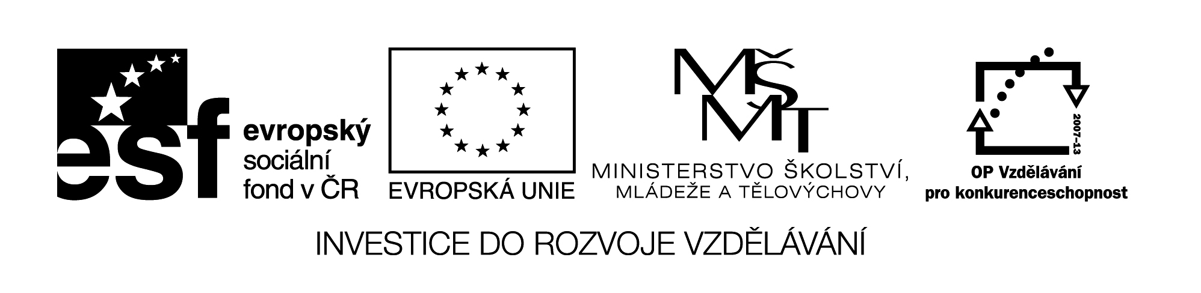

**Název školy:** Střední průmyslová škola, Ostrava - Vítkovice, příspěvková organizace

**Autor:** Mgr. Dagmar Andrysová

**Datum:** 30.7.2012

**Název:** VY_22_INOVACE_1_2_18

**Číslo projektu:** CZ.1.07/1.5.00/34.0125

**Téma:** Počitatelnost podstatných jmen – pracovní list

**Anotace:** DUM; Dokument slouží k procvičení a zopakování učiva Počitatelnost podstatných jmen. Žáci si ústně i písemně opakují učivo.

**Countable and Uncountable Nouns**

**Počitatelnost podstatných jmen**

(pracovní list)

1. **Rozhodněte, zda je vyznačené slovo užito jako počitatelné nebo ne.**
2. People spend their **lives** worrying about money.

How´s **life**?

1. Are you in Prague for **business** or pleasure?

He set up a small travel **business**.

1. The funeral was a painful **experience**.

She´s had ten years´ **experience** as a secretary.

1. Shakespeare´s **language** is magnificent.

It´s easier to work with some who speaks your own **language**..

1. **Vložte do vět slova nebo fráze z rámečku.**

|  |
| --- |
| The advice you gave me information the traffic in London help happiness the news about Tim money the furniture in the living room |

1. I like ____________________. I think it looks very smart.
2. I´d like some ____________about trains, please.
3. You can always call me, if you need any ________.
4. Have you heard _______________________?
5. Money doesn´t always bring ______________.
6. _____________________ is awful – particularly in the rush hour.
7. Do you have any ________ on you? I´d like to buy this t-shirt but don´t have enough.
8. I´d like to thank you for _______________________.
9. **Vyberte vhodný výraz.**
10. *Your hair is/your hairs are* too long. You should have *it/them* cut.
11. I had to buy *some/a* bread because I wanted to make some sandwiches.
12. Sue was very helpful. She gave us some very useful *advice/advices.*
13. I was in a hurry this morning. I didn´t have *time/a time* for breakfast.
14. “Did you enjoy your holiday?“ “Yes, we had *wonderful time/a wonderful time.“*
15. *Light/A light* comes from the sun.
16. **Doplňte do vět *a/an, some* nebo nechte vynechávku prázdnou.**
17. I´ve seen ______good films recently.
18. What´s wrong with you? Have you got _______ headache?
19. I know a lot of people. Most of them are _______ students.
20. When I was _____child, I used to be very shy.
21. What ______beautiful garden!
22. Maria speaks ______ English, but not very much.
23. Would you like to be _______ actor?
24. I´m going shopping. I need to buy _____ bread.
25. Jane is _____ teacher. Her parents were _______ teachers, too.
26. You need ______ visa to visit ______ countries, but not all of them.
27. **Rozdělte výrazy na počitatelné a nepočitatelné.**

|  |  |
| --- | --- |
| Hair shoe bread roll milk child advice information homework shelf air physics rice knowledge book jam chair table mouse table water money window glass | |
| Počitatelná | Nepočitatelná |
|  |  |

1. **Přeložte do češtiny nebo angličtiny.**
2. Chci si koupit dvoje džíny.
3. Líbí se mi její vlasy.
4. Peněženku jsem našla, ale peníze tam už nebyly.
5. Kde je Muzeum českého skla?
6. Dvě sklenky bílého, prosím.
7. Ty chleby kup dva.
8. It was a difficult time for our family.
9. Yesterday he phoned me ten times.
10. Waiter, there is a hair in my soup!
11. Our neighbours make a lot of noise.
12. Our teacher gives us a lot of homework.
13. The main news starts at seven o´clock.

**Seznam použité literatury:**

Cvičebnice anglické gramatiky, nakl. Polyglot, 1999

Intermediate English Grammar, nakl. Collins Cobuild, 2004

English Grammar in Use, nakl. Cambridge, 2009