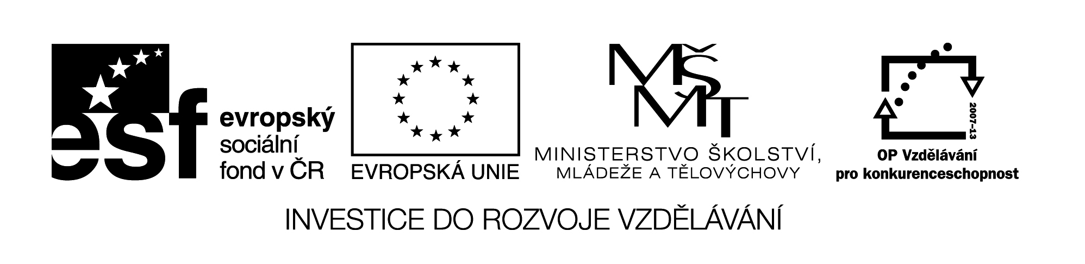

**Název školy:** Střední průmyslová škola, Ostrava - Vítkovice, příspěvková organizace

**Autor:** Mgr. Pavlína Hůrková

**Datum:** 4. 8. 2012

**Název:**VY_22_INOVACE_1.1.8

**Číslo projektu:** CZ.1.07/1.5.00/34.0125

**Téma:** Ostrava and Surroundings

**Anotace:** Pracovní list slouží k procvičení daného učiva, k rozšíření slovní zásoby.

**PRACOVNÍ LIST**

**OSTRAVA AND SURROUNDINGS**

**OSTRAVA A OKOLÍ**

**Cv.1: Try to find on the map some interesting places of our region. What do you know about them? Have you ever visited any of them?**

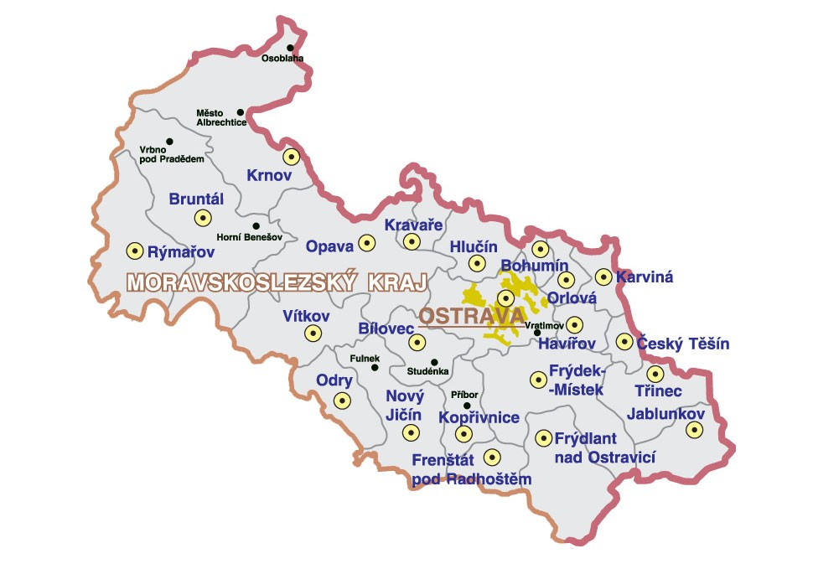

**Cv.2: Use each word only once to complete the sentences.**

|  |  |  |  |  |
| --- | --- | --- | --- | --- |
| MUSIC | POLLUTION | PHENOMENON | MORAVIAN | NATIONAL |
| CHURCH | FLOODS | ESTABLISHED | THIRD | SPECIES |
| STADIUMS | MINES | ENVIRONMENT | OPEN-AIR | HEAVY |

1. Ostrava is the ………. largest town in the Czech Republic.
2. Ostrava was usually seen as a city of ……….. industry.
3. The town’s statute was ……….. in 1267.
4. There were the worst ………. in 1000 years on the Odra, Opava and Ostravice rivers.
5. St.Wenceslas ………. is the oldest remaining building in the city.
6. The ……….. -Silesian National Theatre has two buildings: the Antonín Dvořák Theatre and the Jiří Myron Theatre.
7. The Vítkovice Steelworks concentrates on metallurgy and machine………….
8. The oldest part of the company, called Dolní Vítkovice, is an industrial ………. museum.
9. All underground coal ……….. were closed down after the Velvet revolution in 1989.
10. The area around Stodolní Street has recently become a new ……….. in Ostrava.
11. The Colours of Ostrava is the international ………. festival helding in July.
12. Ostrava ZOO was opened in 1951, it houses around 300 ……….. of animals.
13. There are many ……… (Bazaly, Sareza..), Palace of Culture and Sport, many sport centres etc.
14. It is necessary to improve the ………. n Ostrava.

15. Ostrava’s greatest problem is air ……….. and dirtiness.

Zdroje: Wikimedia Commons.com

Testové úlohy a cvičení jsou autorsky vytvořeny přímo pro učební materiál.