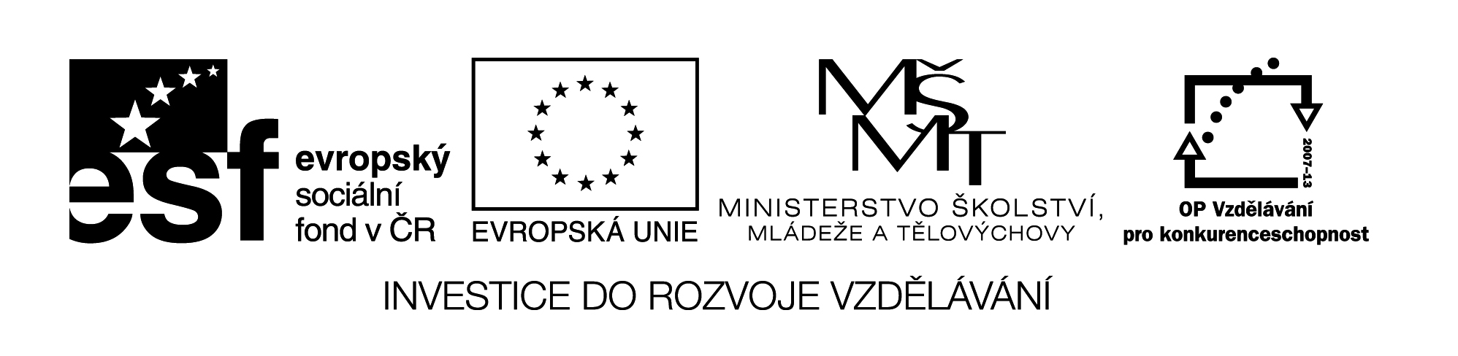

**Název školy:** Střední průmyslová škola, Ostrava - Vítkovice, příspěvková organizace

**Autor:** Mgr. Pavlína Hůrková

**Datum:** 15. 8. 2012

**Název:** VY_22_INOVACE_1.1.32

**Číslo projektu:** CZ.1.07/1.5.00/34.0125

**Sada: 1 Reálie**

**Téma:** American Literature

**Anotace:** Pracovní list slouží k procvičení daného učiva, k rozšíření slovní zásoby.

Cílová skupina – 3.,4. ročník.

**Pracovní list**

**AMERICAN LITERATURE**

**Americká literatura**

**Cv.1: Match the following titles with American authors.**

Twain The Old Man and the Sea

Styron The Great Gatsby

Hemingway Sophie’s Choice

Kerouac Moby Dick

Heller The Call of the Wild

Fitzgerald On the Road

Poe Of Mice and Men

Melville Catch-22

London Babbit

Steinbeck The Raven

Lewis The Adventures of Tom Sawyer

**Cv.2: Use each word only once to complete the sentences.**

|  |  |  |  |  |
| --- | --- | --- | --- | --- |
| **INDIAN** | **STEAMBOAT** | **INTELLECTUAL** | **SMUGGLING** | **JOURNALIST** |
| **POST-WAR** | **FIGHT** | **HORROR** | **BEAT** | **WIN** |

1. Romantic writers were proud of the American ………….. traditions which created their republic.
2. J.F. Cooper described American wilderness and wrote ………….. novels of adventures.
3. E.A Poe is the author of many …………… stories.
4. *Moby Dick* is a famous symbolic novel about …………… between an obsessed man and an animal.
5. M. Twain worked as a …………… pilot on the Mississippi river.
6. Hemingway worked as a ...............
7. *The Great Gatsby* is a novel about a very rich man who earns all his money by ……………
8. S. Lewis was the first US writer to …………..the Nobel Prize in literature in 1930.
9. J.D. Salinger expressed the feelings of the ………….. generation in *the Catcher in the Rye.*

10. On the road – it was the bible of the ................ group.

Zdroje: Testové úlohy a cvičení jsou autorsky vytvořeny přímo pro učební materiál.