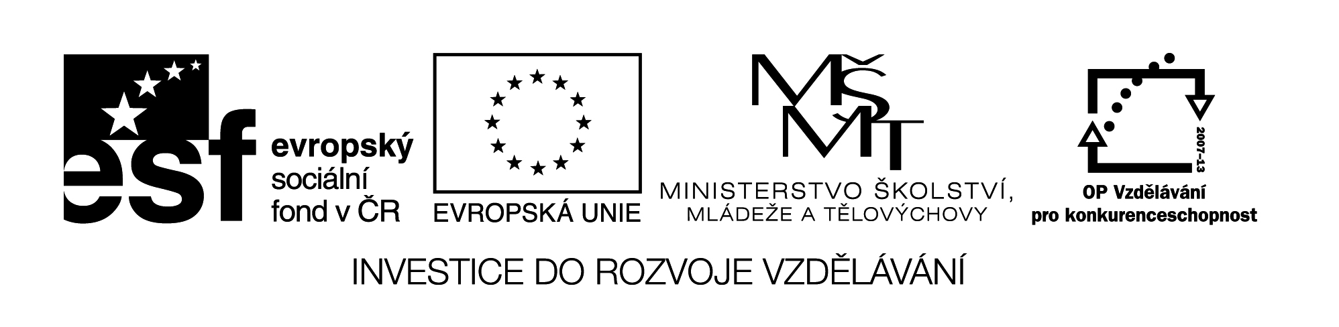

**Název školy:** Střední průmyslová škola, Ostrava - Vítkovice, příspěvková organizace

**Autor:** Mgr. Pavlína Hůrková

**Datum:** 11. 8. 2012

**Název:** VY_22_INOVACE_ 1.1.30

**Číslo projektu:** CZ.1.07/1.5.00/34.0125

**Sada: 1 Reálie**

**Téma:** British Literature

**Anotace:** Pracovní list slouží k procvičení daného učiva, k rozšíření slovní zásoby.

Cílová skupina – 3.,4. Ročník.

**Pracovní list**

**BRITISH LITERATURE**

**Britská literatura**

**Cv.1: Match the following titles with their authors.**

Chaucer *Pride and Prejudice*

Byron *Oliver Twist*

Shakespeare *Ivanhoe*

Shaw *The Canterbury Tales*

Dickens *Childe Harold’s Pilgrimage*

Moore *As you Like It*

Swift *Utopia*

Austen *Gulliver’s Travels*

Scott *Pygmalion*

**Cv.2: Find the Czech translations of comedies by Shakespeare**.

As you like it? Zkrocení zlé ženy

Much Ado about Nothing Sen noci svatojánské

The Comedy of Errors Kupec benátský

The Taming of the Shrew Jak se vám líbí?

Merry Wives of Windsor Mnoho povyku pro nic

The Merchant of Venice Komedie omylů

A Midsummer-Night’s Dream Zkrocení zlé ženy

**Cv.3: Use each word only once to complete the sentences.**

|  |  |  |  |
| --- | --- | --- | --- |
| **DESCRIBED** | **FOUNDER** | **EXPERIMENTAL** | **AWARDED** |
| **TALES** | **DEVELOPING** | **PAGAN** | **SATIRICAL** |
| **JOURNALIST** | **PERIOD** | **DETECTIVE** | **SONNETS** |

1. Old English literature was influenced by …………… traditions.
2. *The Canterbury* …………… is the most famous work written by Geoffrey Chaucer.
3. Shakespeare wrote 37 plays and beautiful ……………
4. Daniel Defoe was a politician, traveller and ……………
5. Jonathan Swift wrote ………….. proze Gulliver’s Travels.
6. The romantic …………… is known especially for its poets.
7. Sir Walter Scott is a …………… of historical novel.
8. Charles Dickens …………… truly the life of poor people in England in 19th century.
9. Dickens showed the negative side of the ................ industrial Britain.
10. Agatha Christie is the Queen of …………… fiction.
11. Rudyard Kipling was ………….. the Nobel Prize for literature in 1907 as the first British author. *(Jungle Book)*
12. The ................. writing is represented by George Orwell and William Golding.

Zdroje: Testové úlohy a cvičení jsou autorsky vytvořeny přímo pro učební materiál.