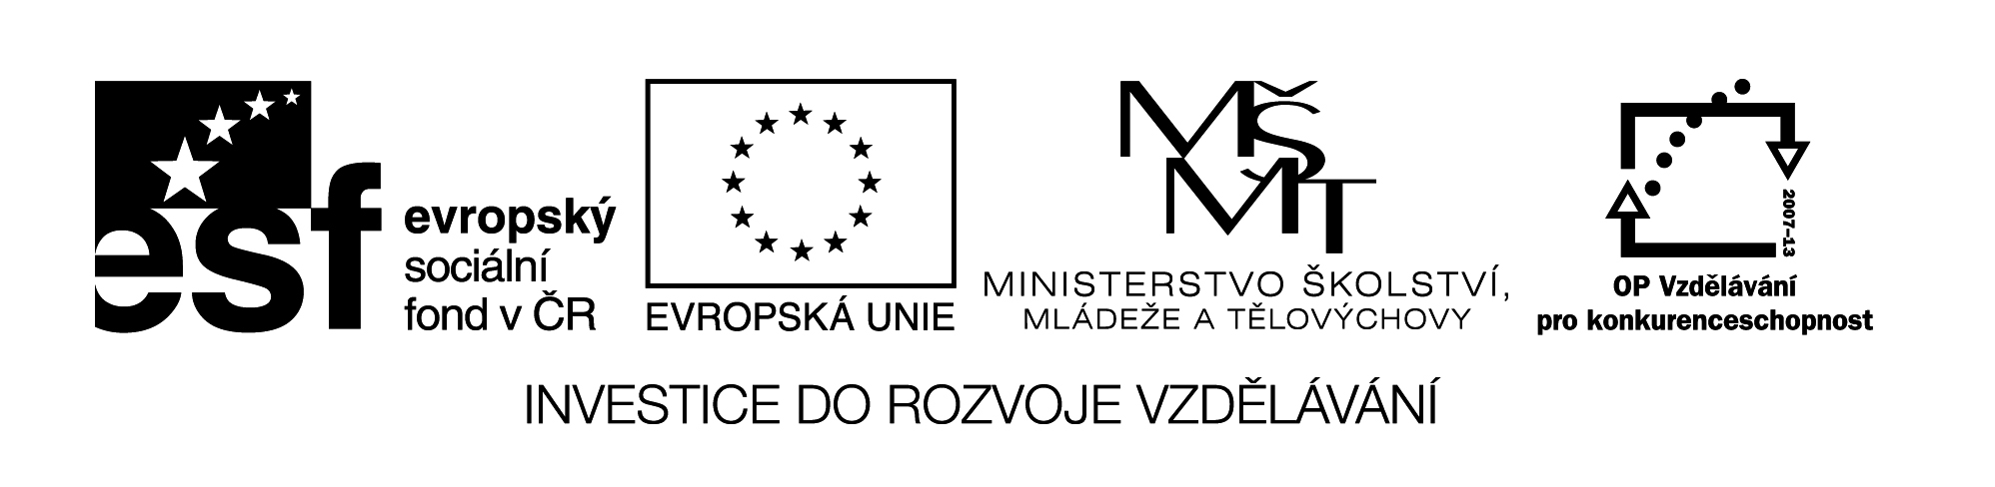

**Název školy:** Střední průmyslová škola, Ostrava - Vítkovice, příspěvková organizace

**Autor:** Mgr. Dagmar Andrysová

**Datum:** 24.8.2012

**Název:** VY_22_INOVACE_1_1_26

**Číslo projektu:** CZ.1.07/1.5.00/34.0125

**Sada: 1 Reálie**

**Téma:** Canada

**Anotace:** DUM; Dokument slouží k procvičení a zopakování učiva Canada. Žáci si ústně i písemně opakují učivo. Cílová skupina: 3.a 4. ročník.

**CANADA**

**KANADA**

**(pracovní list)**

1. **Complete the text about Canada with the words from the box.**

|  |
| --- |
| Vancouver second Great Bear Montreal northern ten French Ottawa British monarch Quebec 30 million Calgary southern forests St. Lawrence North America Yucon islands USA west Great Slave Mt Logan Toronto cold dominion immigrants |

1. It´s the _______largest country in the world but it has only ____________people because it lies in the _______part of ______ _________ and the climate is very ______: arctic and cold mild. Most of people live in the ________ part near the border with ______ (= its only neighbour).
2. One sixth of Canada are the ________, three quarters are the _________. Large mountains are in the _______ - Cordilleras with the highest point - ___________ (6,050 m). Most of the year there is snow in large part of Canada. It has large resources of fresh water in the rivers (__________,__________), lakes (___________,__________) and the glacier.
3. The original inhabitants are indians and eskimos (inuits) but now Canada is the country of _________like the U.S.A. (especially from Europe). Since 16th century Canada was _______ colony called New France. After the war it became an English colony in 1763. Now it´s a ___________ of Great Britain with __________ _______ as an official head of state. Capital city is _________ (about 1 mil. people) – it´s administrative centre.
4. Canada is federal state which consists of ____ provinces and two territories. One province (________) is French speaking. ____________(3.5 mil. people) is the largest French city in the world outside France.

Other large cities: ___________________________________________________

1. **Match the expressions to the names and to the pictures.**
2. lake
3. capital city
4. the highest mountain
5. French speaking province
6. olympic city
7. natural wonder
8. Quebec
9. Montreal
10. Ottawa
11. Niagara Falls
12. Mt. Logan
13. Great Slave
14. B)

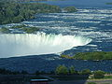 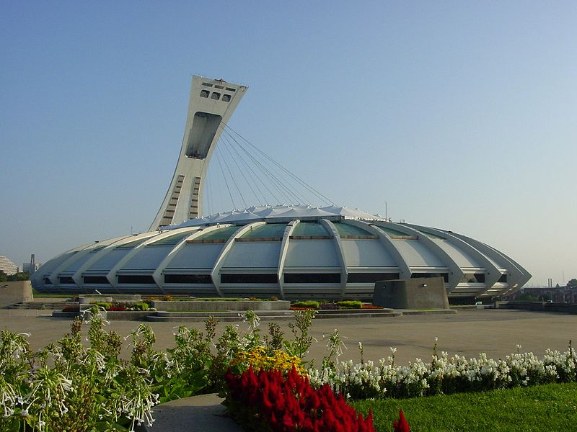

C)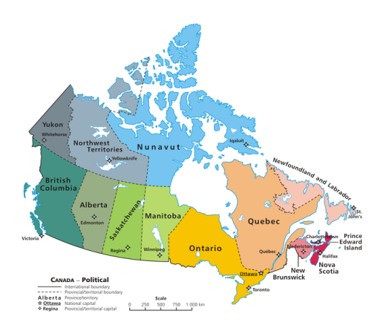 D) 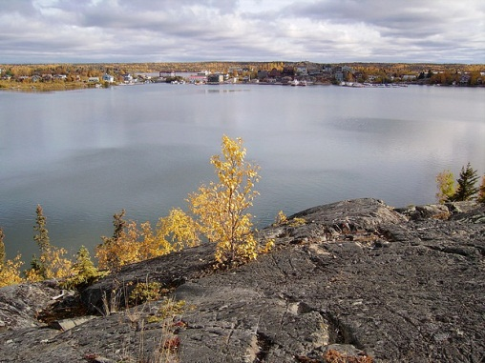

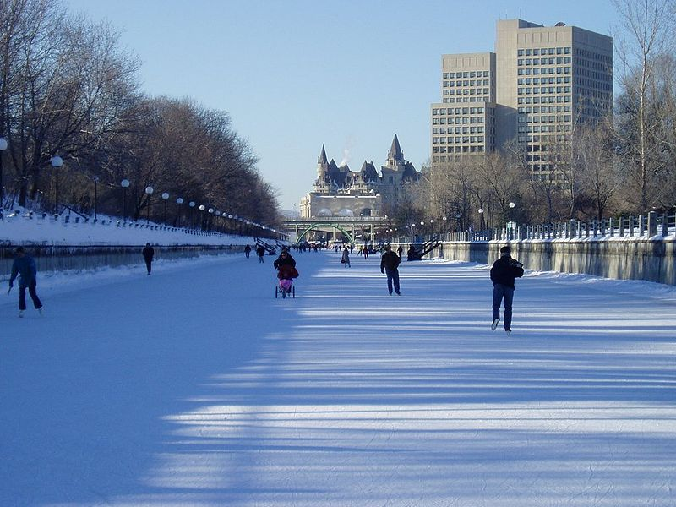 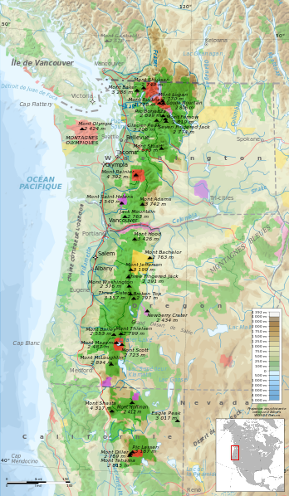

E) F)

**Seznam použité literatury:**

Wikimedia commons

Testové úlohy a cvičení jsou autorsky vytvořeny pro učební materiál.