,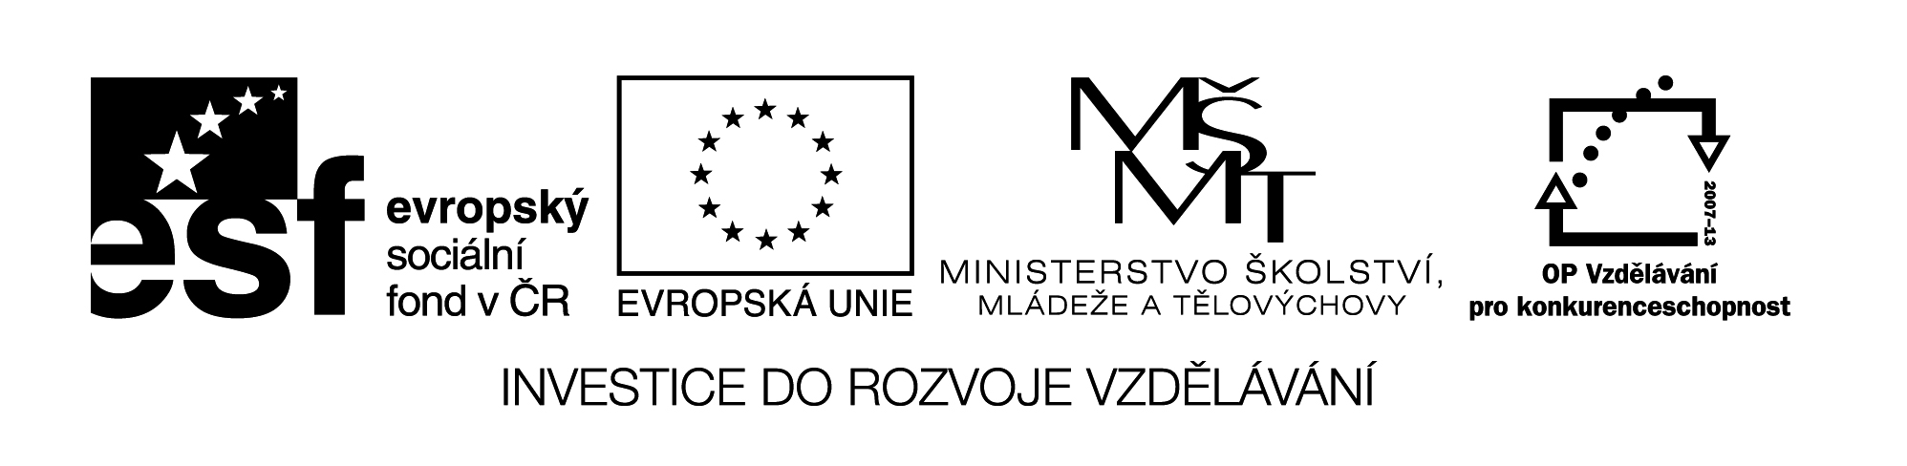

**Název školy:** Střední průmyslová škola, Ostrava - Vítkovice, příspěvková organizace

**Autor:** Mgr. Pavlína Hůrková

**Datum:** 20. 8. 2012

**Název:** VY_22_INOVACE_1.1.24

**Číslo projektu:** CZ.1.07/1.5.00/34.0125

**Sada: 1 Reálie**

**Téma:** Australia

**Anotace:** Pracovní list slouží k upevnění vědomostí daného tématu a k rozšíření slovní zásoby.

Cílová skupina – 3., 4. ročník.

**PRACOVNÍ LIST**

**AUSTRALIA**

AUSTRÁLIE

**Cv.1: Say a few words about Australia. You can use the map. The following questions may help you.**

: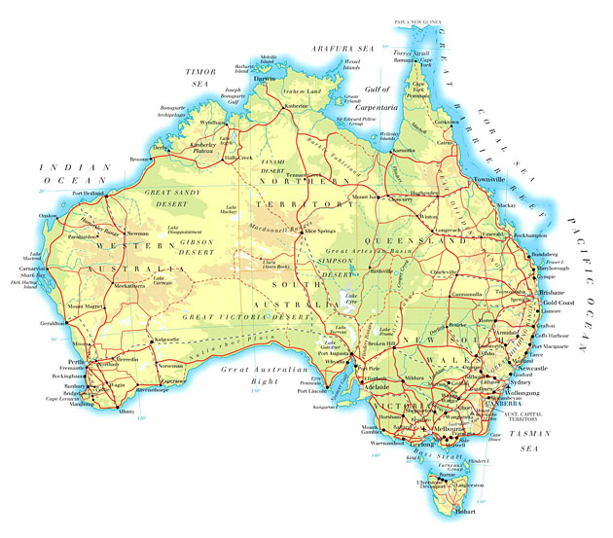

Questions:

1. How large is the area and population of Australia?
2. Where is Australia situated?
3. What do you know about its history?
4. What kind of climate is there?
5. Who were the original inhabitants?
6. What are the typical Australian animals and plants?
7. Which are its main deserts, mountains and rivers?
8. What is the political system in Australia?
9. Which are the largest cities?
10. Who were the first Australian settlers?
11. What mineral resources are there in Australia?
12. Which is the highest mountain in Australia?
13. Do you know any famous Australians?
14. Who is the official head of Australia?

**Cv.3: Use each word from the box only once to complete the sentences.**

|  |  |  |  |  |  |
| --- | --- | --- | --- | --- | --- |
| BEEF | DESERT | SEPARATED | PARADISE | INHABITANTS | GLACIAL |
| REACHED | FLAG | TERRITORIES | ABORIGINES | SOUTHEAST | ANCIENT |

1. Australia has a population of about 22 million ……………
2. Captain James Cook …………..the eastern coast in 1770.
3. Australian population is a mixture of various nationalities but the original inhabitants are called …………..
4. Around 85% of Australians live in urban areas mainly along the …………… coast.
5. There are many plains in Australia and a great part of the surface is ……………
6. Queensland is a popular holiday state – the surfer’s …………, long deserted beaches, diving on the Great Barrier Reef.
7. In Tasmania we can see many national parks with …………… lakes and alpine meadows.
8. Uluru is a 3.6 km long monolith, sandstone formation which has many waterholes, rock caves and …………… paintings.
9. As the island is …………… from the rest of the world, Australia has a lot of unique animals.
10. Australia belongs to the top exporters of …………, lamb, wool and wheat.

11. The Commonwealth of Australia consists of 6 states and 2 ……………

12. The Australian ………….. consists of a small Union Jack and the Southern Cross constellation.

Zdroje: Smith-Dluhá, G.: Angličtina, otázky a odpovědi. Infoa, 2008.

Odehnalová, J.: Reading about the English-speaking Countries. Práh, 1992.

Testové úlohy a cvičení jsou autorsky vytvořeny pro učební materiál.