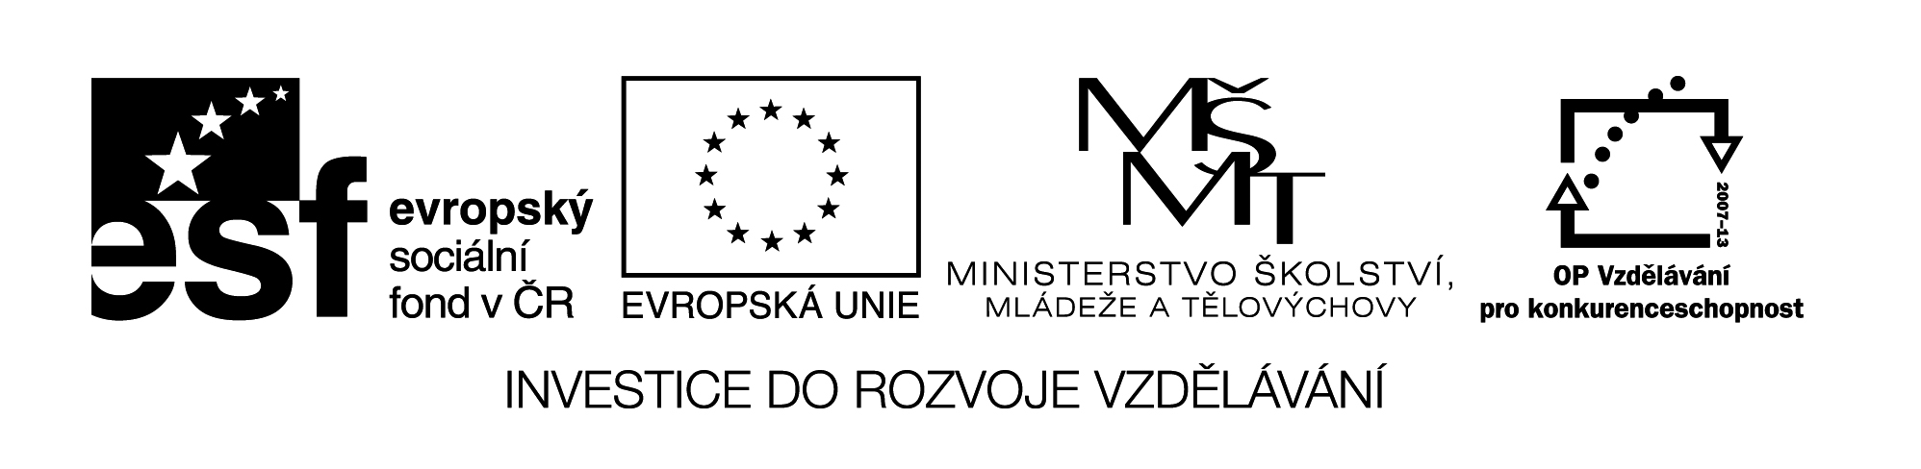

**Název školy:** Střední průmyslová škola, Ostrava - Vítkovice, příspěvková organizace

**Autor:** Mgr. Dagmar Andrysová

**Datum:** 23.8.2012

**Název:** VY_22_INOVACE_1_1_2

**Číslo projektu:** CZ.1.07/1.5.00/34.0125

**Téma:** The European Union – pracovní list

**Anotace:** DUM; Dokument slouží k procvičení a zopakování učiva Evropská unie. Žáci si ústně i písemně opakují učivo**THE EUROPEAN UNION**

**Evropská unie**

**(pracovní list)**

1. **Name the member states and shortly describe the history of the European union.**

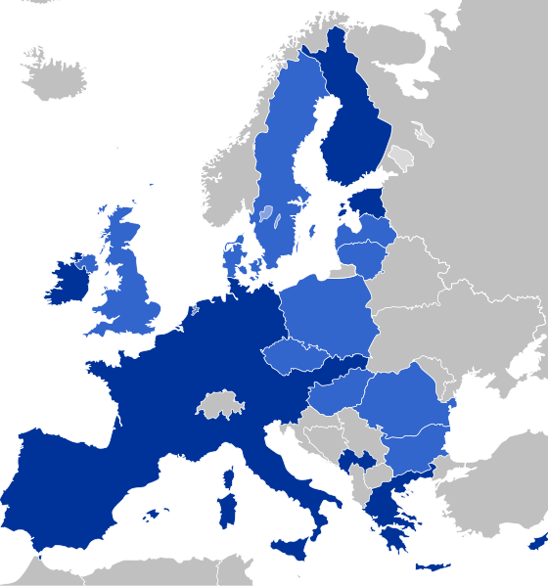



1. **Match the institutions to their functions.**
2. The European comission
3. The council of the EU
4. The European parliament
5. European court of auditors
6. The European bank
7. The European court of justice
8. controls investments
9. has legislative and monitoring powers
10. coordinates application of the laws in all member states
11. has executive power
12. represents the government of the member states
13. is responsible for currency issues and the euro
14. **Complete the sentences with the words from the box.**

|  |
| --- |
| Germany job opportunities peace population Switzerland currency stronger Italy the environment more stable European Economic Comunity |

1. The European union was founded as ____________________________in 1957.
2. The original six member states included: Belgium, ___________, France, ____________, Luxembourg and the Netherlands.
3. _____________ is not a member of the EU.
4. Some of the EU principles are:

Fewer borders – more __________________.

Euro – a single ____________ for Europe.

The care of _________________ .

Keeping the ______________ .

Enlargement towards a ______________ and __________________ Europe.

1. The EU now has a _________________ of about 500 million.

**Seznam použité literatury:**

Angličtina otázky a odpovědi nejen k maturitě, nakl. INFOA, 2008

Wikimedia commons

Testové úlohy a cvičení jsou autorsky vytvořeny pro učební materiál.