

**Název školy:** Střední průmyslová škola, Ostrava - Vítkovice, příspěvková organizace

**Autor:** Mgr. Dagmar Andrysová

**Datum:** 23.8.2012

**Název:** VY_22_INOVACE_1_1_18

**Číslo projektu:** CZ.1.07/1.5.00/34.0125

**Téma:** USA – pracovní list

**Anotace:** DUM; Dokument slouží k procvičení a zopakování učiva USA. Žáci si ústně i písemně opakují učivo.

**UNITED STATES OF AMERICA**

**SPOJENÉ STÁTY AMERICKÉ**

**(pracovní list)**

1. **Complete the text about the U.S.A. with the words from the box. The map may help you.**

|  |
| --- |
| **Washington, D.C. north of American continent Mexico Cordilla arctic Mississippi Yucon Canada Alaska Colorado Ontario 50 Yellowstone inuits east Cristopher Columbus Grand Canyon Arctic salad bowl Great Britain Superior Missouri independence Michigan Civil slavery indians 1492 Yosemite Erie Huron Appalachians moderate Florida Hawaii the north tropical Pacific Mt. Mac Kinley subtropical 4th federation** |

1. USA is a ________________ of _____ states with capital city _________________ .
2. Two states lying outside the main part are __________ and _________ .
3. It is the ______ largest country in the world (after Russia, Canada and China).
4. It lies in the ____________________________ surrounded by Atlantic, _________ and _______________ oceans. Its neighbourghs are ___________ and __________ .
5. The largest mountain range is ___________ with the highest mountain ____________ (over 6 thousand m above the sea level) in Alaska.
6. The only mountains in the east are the _____________ .
7. The climate is various (large country): from _______ in Alaska to ________ in Hawaii. Most of the main part has ___________ climate, only in _________ and California there is subtropical climate.
8. The longest rivers are __________ and __________ (4th in the world), some other rivers: _______, _________,…..
9. On the border with Canada we can find 5 Great Lakes: __________ , __________ , _________ , ____________ and __________ with Niagara Falls.
10. USA has a lot of beautiful countryside. Some parts are protected in National Parks. Examples: ___________ , ____________ , _____________ …….
11. The original inhabitants are _________ and ________ living mostly in the reserves. USA is sometimes called the ________ ______ or „melting pot“ – it means that most of its inhabitants are immigrants.
12. America was discovered in ______ by _________ __________ . Its colonisation started from the _______, so most of large cities lay on this coast.
13. USA was a colony of _______ ________ until the war of _______ in 1775 – 1783. 4th July 1776 13 states declared their independence.
14. The last war at the area of USA was the ________ war in 1861 – 1865 between the North and the South about the slavery. The _______ won and the __________ was abolished.

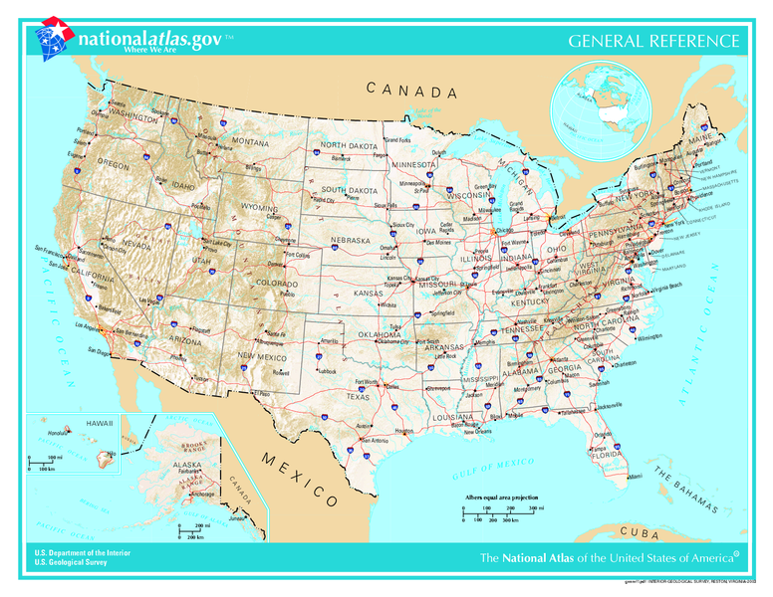

**Seznam použité literatury:**

Wikimedia commons

Testové úlohy a cvičení jsou autorsky vytvořeny pro učební materiál.