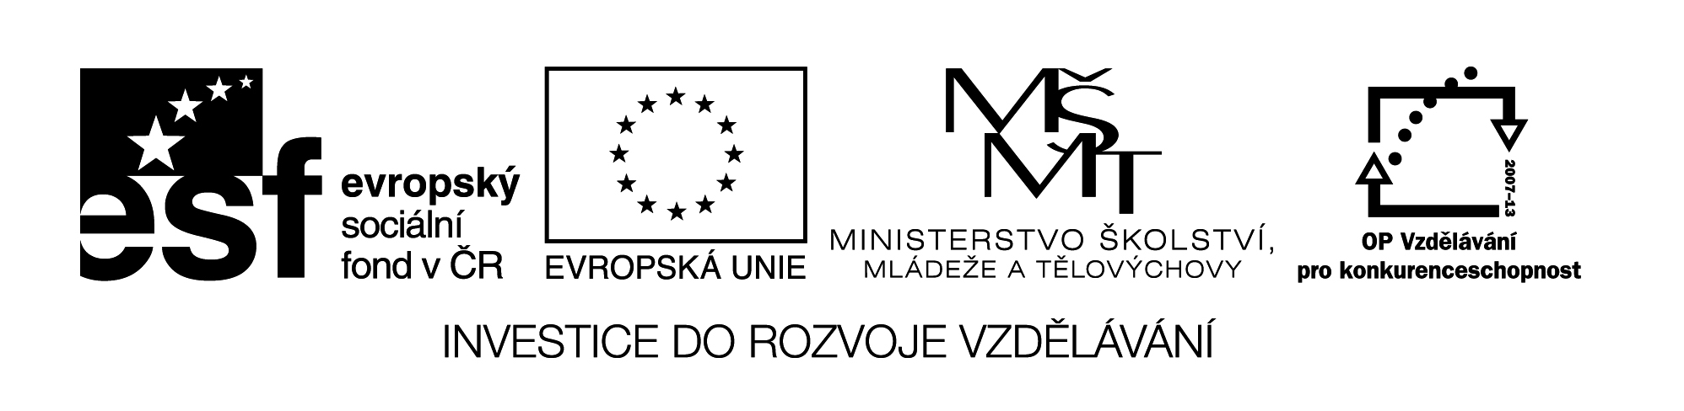

**Název školy:** Střední průmyslová škola, Ostrava - Vítkovice, příspěvková organizace

**Autor:**  Mgr. Pavlína Hůrková

**Datum:** 17. 8. 2012

**Název: VY_22_INOVACE_1.1.16**

**Číslo projektu:** CZ.1.07/1.5.00/34.0125

**Téma:** Scotland

**Anotace:** Pracovní list slouží k ověření znalostí žáků probraného učiva a k rozšíření slovní zásoby.

**PRACOVNÍ LIST**

**SCOTLAND**

**SKOTSKO**

**Cv. 1: What are the following Scottish personalities famous for?**

1. William Wallace a. actor
2. Alexander Fleming b. historical figure
3. Alexander Graham Bell c. poet
4. James Watt d. invented the TV
5. Charles Mackintosh e. discovered penicillin
6. Robert Burns f. author of *Treasure Island*
7. Robert Luis Stevenson g. designer of raincoat
8. Sir Arthur Conan Doyle h. invented the steam engine
9. Sir Sean Connery i. historical figure
10. David Coulthard j. author of the Sherlock Holmes stories
11. Robert the Bruce k. invented telephone
12. John Logie Baird l. racing driver

**Cv. 2: Say a few words about Scotland. You can use the following map.**

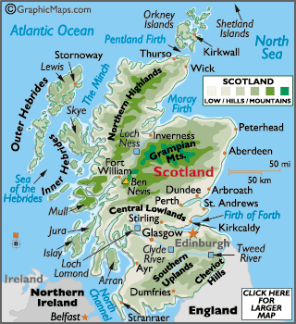

**Cv. 3: Use each word only once to complete the sentences.**

|  |  |  |  |  |  |  |
| --- | --- | --- | --- | --- | --- | --- |
| **EDUCATIONAL** | **BLOW** | **BAGPIPES** | **BARLEY** | **TOSSING** | **DOMINATED** | **ORGANS** |
| **MONSTER** | **EMBLEM** | **UNSPOILED** | **TARTAN** | **SHIPBUILDING** | **GAELIC** | **DRAMA** |

1. Scotland is famous for four things: ..............., kilts, haggis and whisky.
2. The kilt is made of ............... - a kind of woollen cloth.
3. Each Scottish family or clan has its own different tartan as an............... .
4. Haggis, Scottish national dish, is made from sheep’s internal.................
5. Whisky is made from water and ...............and fermented with yeast.
6. A bag of bagpipes made traditionally from a sheep’s stomach is squeezed under the arm to ...............air through the pipes.
7. The official language is English, although ..............is spoken.
8. Edinburgh is ............. by its imposing 12th century castle Holyroodhouse.
9. In August The Edinburgh International Festival of Music and ............... is held.
10. The biggest city Glasgow is famous for its ...............industry.
11. The scenery in the Highlands, with their lonely and ............... countryside, is beautiful.
12. Scotland has its own legal and ............... systems.
13. Loch Ness is famous for its ...............-
14. The Scotsmen love their traditional sports like ............... the caber or hammer and a tug-of-war.

Zdroje: Smith-Dluhá, G.: Angličtina, otázky a odpovědi. Infoa, 2008.

Odehnalová, J.: Reading About the English-Speaking Countries.

Testové úlohy a cvičení jsou autorsky vytvořeny přímo pro učební materiál.