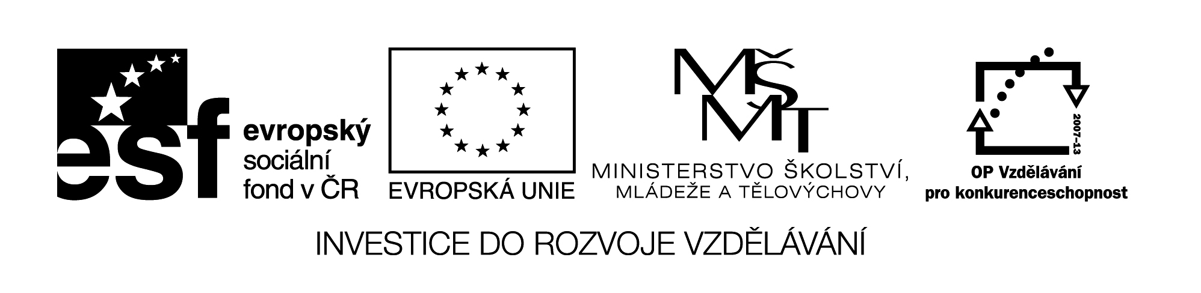

**Název školy:** Střední průmyslová škola, Ostrava - Vítkovice, příspěvková organizace

**Autor:** Mgr. Pavlína Hůrková

**Datum:** 5. 8. 2012

**Název:** VY_22_INOVACE_1.1.14

**Číslo projektu:** CZ.1.07/1.5.00/34.0125

**Téma:** British Places of Interest

**Anotace:** Pracovní list slouží k procvičení daného tématu k rozšíření slovní zásoby.

**PRACOVNÍ LIST**

**BRITISH PLACES OF INTEREST**

**ZAJÍMAVÁ MÍSTA VELKÉ BRITÁNIE**

**Cv.1: Try to mark on the map some British interesting places.**

|  |
| --- |
| http://www.veselyskolniautobus.cz/IS/pu_data/send_files/Image/user_img/veselyskolniautobus_cz/za/anglie.gif |

**Cv.2: Complete the names of interesting British places**.

GSTHNENOEE

SOWGLGA

RTRVBCAEYN

GNOHBIRT

EBN ESVNI

OPILLEVOR

HCOL NSES

HNREIDUBG

ROOXFD

LCNWALRO

ORDEV

EMDBIRCGA

**Cv.3: Use each word only once to complete the sentences.**

|  |  |  |  |  |  |
| --- | --- | --- | --- | --- | --- |
| **ROMANTIC** | **FERRY** | **UNIVERSITY** | **RESORT** | **MUSEUM** | **GLASGOW** |
| **CATHEDRAL** | **RIVIERA** | **EDINBURGH** | **MONSTER** | **CASTLE** | **BIRTHPLACE** |

1. Oxford and Cambridge are the oldest …………… towns.

2. Canterbury is an ancient city with a majestic …………… .

3. In Manchester we can visit The …………… of Science and Industry.

4. Stratford-upon- Avon is the …………… of William Shakespeare.

5. Brighton lies on the southern coast of England. It is a famous seaside ……………. .

6. The Lake District National Park is the region where …………… poet Wordsworth wrote his poetry.

7. The coast of Cornwall is called English .......... as there are sandy beaches and palm trees.

8. The biggest Scottish city is ………….. .

9. …………… is full of attractive squares, tree-lined avenues and elegant shopping centres like Princess Street.

10. Loch Ness is famous for its Loch Ness …………… .

11. Dover is a major …………… port in South-East England.

12. Caernarfon is the best known …………… in Wales.

Zdroje: Wikimedia Commons.com

Testové úlohy a cvičení jsou autorsky vytvořeny přímo pro učební materiál.