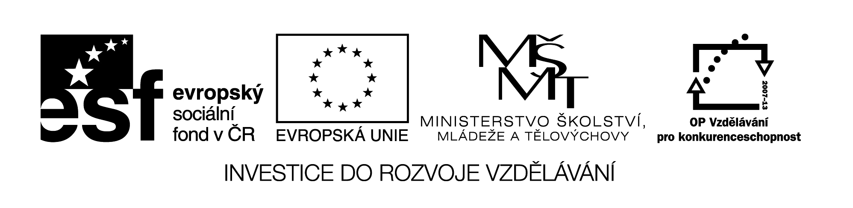

**Název školy:** Střední průmyslová škola, Ostrava - Vítkovice, příspěvková organizace

**Autor:** Mgr. Dagmar Andrysová

**Datum:** 23.8.2012

**Název:** VY_22_INOVACE_1_1_10

**Číslo projektu:** CZ.1.07/1.5.00/34.0125

**Téma:** Great Britain – pracovní list

**Anotace:** DUM; Dokument slouží k procvičení a zopakování učiva Great Britain. Žáci si ústně i písemně opakují učivo.

**GREAT BRITAIN**

**VELKÁ BRITÁNIE**

**(pracovní list)**

1. **Match the countries to their capitals and show them in the map.**
2. Scotland 1. Cardiff
3. England 2. Edinburgh
4. Wales 3. Belfast
5. Northern Ireland 4. London

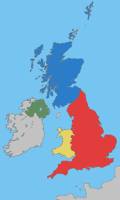

1. **Complete the text about the brief British history with the words from the box.**

|  |
| --- |
| Norman European Union colonies Commonwealth of Nations Australia Hadrian´s wall Victoria sea power Roman Empire pound |

1. Until 43 AD Britain was a part of ________ ________. Even now we can see the roads, baths and the __________ ______ which had marked the border of the Empire.
2. Britain was last conquered in 1066 by _________ king William the Conqueror.
3. After the overseas discoveries Britain competed with Spain to be the world´s greatest _____ ________ .
4. In the 19th century – during the reign of the queen ___________ Britain had a lot of __________ all over the world.
5. The result now (21st century) is the __________________ ___ _____________: group of countries with English as an official language and British monarch as their official head of state. There are for example Canada, __________ and New Zealand.
6. Since 1973 Britain has been a member of the ____________ ______ but has had its own currency – the ________ .
7. **Mark the places in the pictures.**
8. Loch Ness
9. Stonehenge
10. Edinburgh Castle
11. White cliffs of Dover
12. Brighton Royal Pavilion
13. Windsor Castle
14. Falkirk Wheel
15. Hadrian´s Wall
16. Snowdon mountain

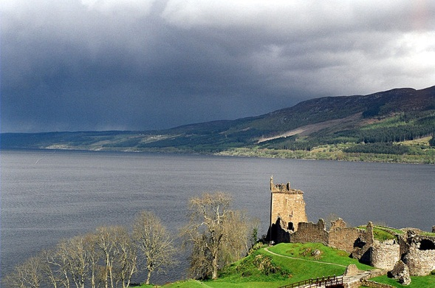 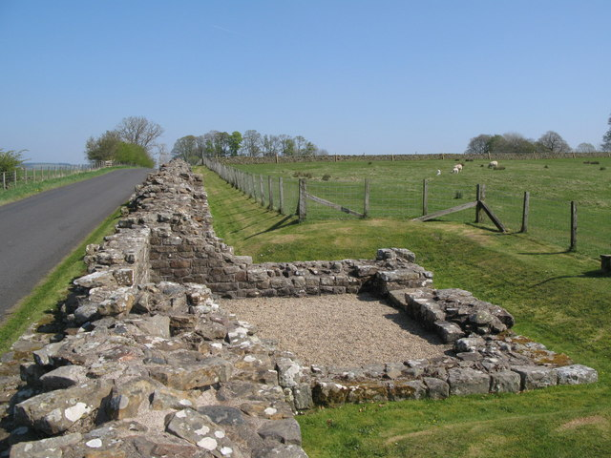 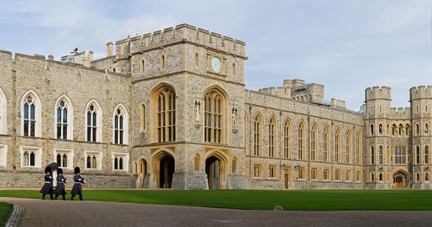

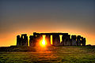 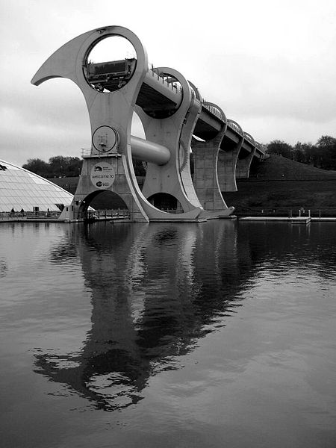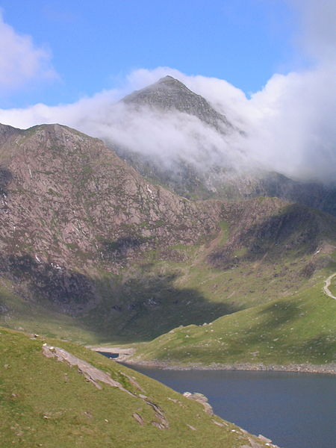 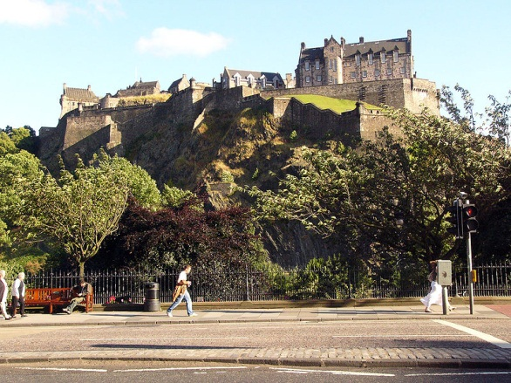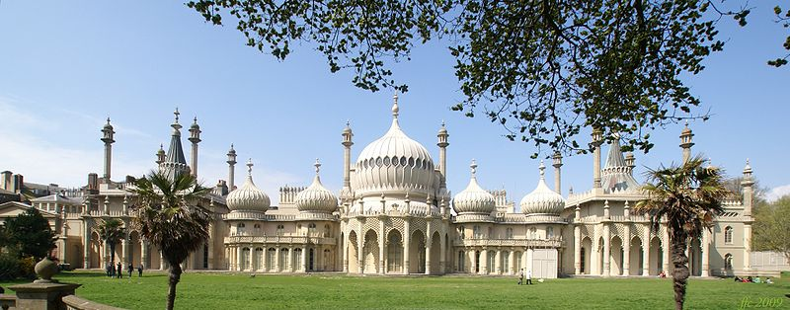 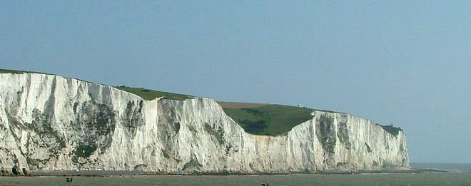

**Seznam použité literatury:**

Wikimedia commons

Testové úlohy a cvičení jsou autorsky vytvořeny pro učební materiál.